School Uniform Policy


Graveney Primary School

Approved by: | Governing Body
Last reviewed on: | July 2026
Next review due by: | July 2027

1. Aims
At Graveney Primary School, we believe that a school uniform promotes a sense of belonging, pride, and equality among our pupils. This policy aims to:
- Set out Graveney Primary School's approach to providing a school uniform that is affordable, practical, and represents good value for money for parents and carers.
- Explain how the school will meet its responsibilities under the Equality Act 2010, ensuring that our uniform requirements do not discriminate against pupils and that reasonable adjustments are made where necessary.
- Clarify our expectations regarding school uniform, appearance, and presentation, helping to create a positive learning environment and a strong sense of community within the school.
- Ensure that all pupils can participate fully in school life regardless of their background, faith, culture, disability, or financial circumstances.
- Support families by keeping branded items to a minimum wherever possible and providing clear guidance on acceptable uniform options.
This policy has been developed with consideration for pupil welfare, inclusivity, affordability, and the needs of the Graveney Primary School community.

2. Our school’s legal duties under the Equality Act 2010
The Equality Act 2010 prohibits discrimination against an individual based on the protected characteristics, which include: age, sex, sexual orientation, disability, race, religion or belief, pregnancy and maternity, and gender reassignment.
To avoid discrimination, our school will:
- Avoid listing uniform items based on sex, to give all pupils the opportunity to wear the uniform they feel most comfortable in
- Make sure that our uniform costs the same for all pupils
- Allow all pupils to have long hair, although we reserve the right to ask that long hair be tied back
- Allow all pupils to style their hair in a way that is appropriate for school, and makes them feel most comfortable
- Allow pupils to request changes to swimwear for religious reasons, or if they are experiencing discomfort
- Allow pupils to wear headscarves and/or other religious garments
- Allow pupils with sensory or physical needs to make reasonable adaptations to their uniform, depending on their specific needs
- Allow for reasonable adaptations to our policy on the grounds of equality by asking pupils or their parents/carers to get in touch with the headteacher, who can answer questions about the policy and respond to any requests. These will be considered on a case-by-case basis

3. Limiting the Cost of School Uniform
At Graveney Primary School, we recognise the financial pressures that some families may face and are committed to keeping the cost of school uniform affordable. We understand that primary-aged children grow quickly and that uniform often needs to be replaced regularly.
In line with Department for Education guidance, we ensure that our uniform offers good value for money and does not place an unnecessary financial burden on families.
To help keep costs low, only two items of our uniform are compulsory and branded with the school logo: the white polo shirt and the school jumper or cardigan. We also offer a range of other optional branded items, such as fleeces, which families may choose to purchase if they wish. However, the branded polo shirt and jumper or cardigan are the only compulsory branded items. All other uniform items can be purchased from a range of retailers, including supermarkets and local suppliers.
We do this by:
- Limiting compulsory branded items to the white polo shirt and school jumper or cardigan.
- Offering additional branded items as optional purchases only.
- Ensuring PE kit consists mainly of unbranded items that can be purchased from a variety of retailers.
- Avoiding specific requirements for coats, bags and footwear.
- Avoiding unnecessary changes to uniform requirements.
- Consulting with parents and carers before making any significant changes to the uniform policy.
- Regularly reviewing our uniform policy to ensure it remains affordable.

Second-hand Uniform
We actively encourage the reuse of school uniform through our free uniform recycling centre. Families can donate or access good-quality second-hand uniform, including branded items, by speaking to the school office. Information about this provision is available on our website and from the school office.
Branded uniform items are available from My Clothing and Rivals in Faversham.

4. Expectations for school uniform

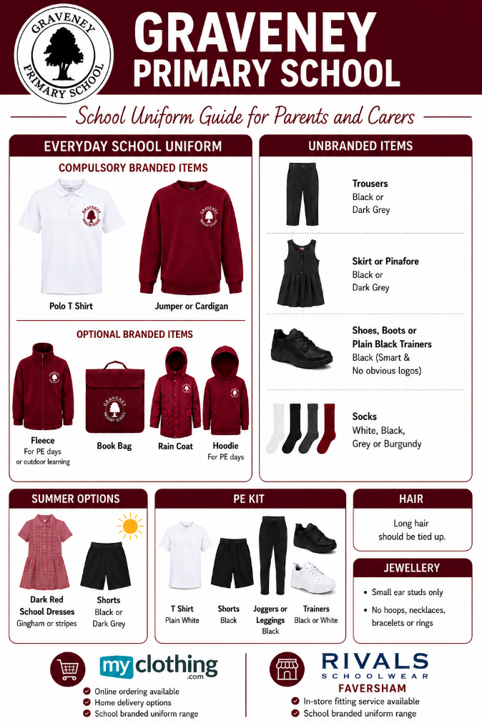

My Clothing
Website: My Clothing
Rivals School & Dancewear
116 West Street, Faversham, Kent, ME13 7JB
Telephone: 01795 590473
Email: sales@rivalschoolwear.co.uk
Website: Rivals School & Dancewear
Parents and carers are welcome to purchase the compulsory branded items from either supplier. All other non-branded uniform items may be purchased from a retailer of their choice.

5. Expectations for our school community
5.1 Pupils
Pupils are expected to wear the correct uniform at all times (other than specified non-school uniform days) while:
- On the school premises
- Travelling to and from school
- At out-of-school events or on trips that are organised by the school, or where they are representing the school (if required)
Pupils are also expected to contact the headteacher if they want to request an amendment to the uniform policy in relation to their protected characteristics.
5.2 Parents and carers
Parents and carers are expected to make sure their child has the correct uniform and PE kit, and that every item is:
- Clean
- Clearly labelled with the child’s name
- In good condition
Parents/carers are also expected to contact the headteacher if they want to request an amendment to the uniform policy in relation to:
- Their child’s protected characteristics
- The cost of the uniform
Parents/carers are expected to log any complaints or objections relating to the school uniform in a timely and reasonable manner in accordance with the school’s complaints policy.
Disputes about the cost of the school uniform will be:
- Resolved locally
- Dealt with in accordance with our school’s complaints policy
The school will work closely with parents/carers to arrive at a mutually acceptable outcome.
5.3 Staff
Staff will monitor pupils' uniform and, where concerns arise, will work with pupils and their families to ensure they understand the school's uniform expectations. Families will be given the opportunity and support to address any issues. Where concerns continue, these will be discussed with the headteacher, who will work in partnership with parents and carers to find a suitable resolution.
The school will work in partnership with parents and carers to address any ongoing concerns regarding school uniform. Where necessary, these concerns will be referred to the headteacher for further discussion and support.
In cases where it is suspected that financial hardship has resulted in a pupil not complying with this uniform policy, staff will take a mindful and considerate approach to resolving the situation and the pupil will not miss classroom teaching because of a sanction. This is in line with the statutory guidance.
5.4 Governors
The governing board will review this policy and make sure that it:
- Is appropriate for our school’s context
- Is implemented fairly across the school
- Takes into account the views of parents/carers, and pupils
- Offers a uniform that is appropriate, practical and safe for all pupils
The board will also make sure that the school’s uniform supplier arrangements give the highest priority to cost and value for money, for example by avoiding single-supplier contracts and by re-tendering contracts at least every 5 years.

6. Monitoring arrangements
This policy will be reviewed annually by the Headteacher. At every review, it will be approved by the Governing Body.

7. Links to other policies
This policy is linked to our:
- Behaviour policy
- Equality information and objectives statement
- Anti-bullying policy
- Complaints policy

