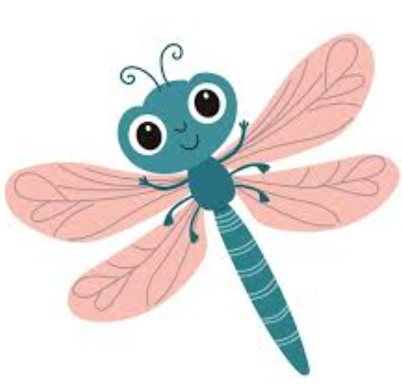
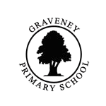
Literacy and Guided Reading

In our reading lessons, we will be reading Egyptian Cinderella by Shirley Climo. Through this text, we will develop our reading skills: widening our vocabulary, making inferences, making predictions, explaining author intentions, retrieving information and summarising. Our writing this term will be based on the text, The Lion, The Witch and The Wardrobe by C.S. Lewis. We will learn to craft a newspaper report and look at ways which are used when writing a non-fiction report.

Curriculum in Dragonflies
Term 6
Maths
This term in maths, pupils will build their confidence with time by reading analogue and digital clocks, including 12- and 24-hour times, explore durations and relationships between seconds, minutes, hours, days, weeks, months, and years in real-life contexts. We will also look at decimals, money and shape. We will finish the year by recapping everything that we heave learned over the year.

Computing: Video trailers: Using iPads
We will explore the purpose of book trailers and create our own using storyboards, photos, videos, and film editing software. We will develop filming and editing skills by considering camera angles, adding text and transitions, and evaluating our own and others’ trailers.

Geography: What are rivers and how are they used?
We will explore rivers and the water cycle by learning about river features, courses, uses, and locations. We will investigate how humans and the environment interact with rivers, use OS maps to identify river locations, and evaluate how river environments can be improved.

PE
This term, pupils will build confidence and teamwork as they develop ball-handling skills in cricket and multi-skills.
Science: Making connections: How does food affect muscle fatigue?
We will explore how food consumption affects energy levels and muscle fatigue through scientific enquiry and practical investigation. We will develop skills in prediction, testing, data collection, and evaluation while learning about nutrition, exercise and healthy lifestyles.

French: Food
We will develop our French language listening, reading and language detective skills while learning about French customs, festivals and traditions, comparing them with those in the UK, and practising how to order typical French food and drink.

RE: Sikhism
We will learn about the origins and beliefs of Sikhism by identifying its founder, Guru Nanak, and exploring Sikh places of worship, known as Gurdwaras. We will also retell a story from a Sikh festival and understand why the Guru Granth Sahib is respected as the eternal and final Guru.

PSHE: Emotional Explorers
Our Emotional Wellbeing Team will be coming in for our PSHE lessons. They will be running a programme called ‘Emotional Explorers’ which explores ways to help children at school with their emotional wellbeing and mental health.
Music: Changes in pitch, tempo and dynamics
We will develop our singing and performance skills by singing in tune, performing ostinatos, and working in harmony with others. We will listen carefully, use musical vocabulary to describe how music makes us feel, and create and perform our own compositions using a variety of ostinatos.

Art: Exploring tone, texture and proportion
We will develop our artistic skills by using tone, texture, proportion, and composition to create detailed artwork and collage pieces. We will explore different techniques, including mark making and impasto, to show light, dark, texture, and space in our work.

