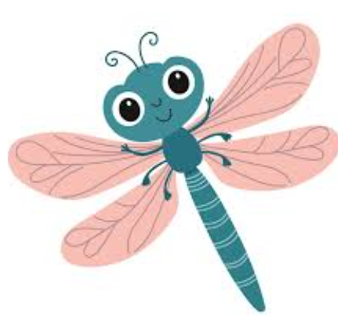
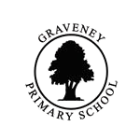
Literacy and Guided Reading

In our reading lessons, we will be reading The Illustrated Atlas of Britain and Ireland by Struan Reid and Megan Cullis. Through this text, we will develop our reading skills: widening our vocabulary, making inferences, making predictions, explaining author intentions, retrieving information and summarising. Our writing this term will be based on the text, Journey by Aaron Becker. We will learn to narrative story, a diary entry and a non-chronological report.

Curriculum in Dragonflies
Term 5
Maths

This term in maths, we will build their confidence with fractions by adding and subtracting simple fractions, comparing fractions understanding equivalent fractions and understanding improper fractions. We will also look at mass and capacity, focusing on developing our ability to measure mass (g and kg), measure capacity in volume (ml and l), add and subtract mass and compare mass and capacity.

Computing: Website design
We will learn how to design and create our own web content, including planning and building a Sway with a clear title, images and organised sections. We will develop our ideas by creating plans and using checklists to include a range of features. As we progress, we will create professional-looking web pages that are well-structured, easy to read, and help users to quickly find useful information.

History: Who were the Romans?
We will learn about Ancient Rome, including what life was like and what people valued. We will explore key terms such as empire, invasion and settlement, and investigate the Roman invasion of Britain and how the Celts responded. We will also learn why the Roman army was so successful and consider the lasting impact the Romans had on Britain.

PE
This term, pupils will build confidence and teamwork as they develop skills in OAA and movement through athletics.
Science: Animals including humans; nutrition and movement
We will learn about the human body, focusing on the skeleton and muscles, including how they support, protect and help us to move. We will explore different types of animals, comparing vertebrates and invertebrates, and understand how their skeletons differ. We will also learn about healthy eating, including the main nutrient groups, how food provides energy, and how to make balanced choices.

RE: Hindu Dhamra
We will learn about Hinduism, including its key beliefs, important symbols and deities, and where Hindus worship. We will explore how Hinduism began, look at special festivals and stories, and understand how worship can take place both at home and in a Mandir. We will also begin to learn about Hindu holy books and what they teach.

French: Colourful creatures
We will develop our French by learning vocabulary patterns, using a dictionary. We will apply basic grammar rules for noun gender and adjective agreement, and begin to build sentences while noticing differences between French and English word order.

PSHE: Emotional Explorers
Our Emotional Wellbeing Team will be coming in for our PSHE lessons. They will be running a programme called ‘Emotional Explorers’ which explores ways to help children at school with their emotional wellbeing and mental health.
Music: Adapting and transposing motifs
We will learn a new song and sing in time and in tune. We will create, play and record simple musical motifs, and explore how to change and combine them to perform as a group.
DT: Structures; Constructing a castle
We will learn about castles and their key features, including how they are designed for a purpose. We will explore how castles are made from simple 3D shapes and practise cutting, shaping and assembling materials to build our own structures. We will also develop our skills in designing, making and evaluating our work.

